Back2School Protocols & Reopening Plan

2020-2021 School Year
Unanimously approved by the School Board of Calvary Christian Schools,
Fruitport, MI on August 17, 2020.

CCS is a K-12 school with thirteen class cohorts* averaging 15 students. The intention of this plan is to keep cohort groups intact throughout the day, and to limit cross-traffic between cohort groups as much as possible.

*A cohort is an age-group/grade-level that remains together as a unit for the entire or nearly entire day. Unlike larger schools, at CCS the single grade/single cohort is true for all grades, K-12.

SCHOOL DAY PROTOCOLS:

DROP OFF: Cross-traffic between grade cohorts*, and parking lot congestion during peak traffic times, will be mitigated by the following updated parent “drop off and pick up” plan (see diagram):
- Preschool and Kindergarten parents will enter the west driveway at the Calvary Christian Schools sign (marked entrance A). The kindergarten classroom is in its same location, and Preschool has been relocated to the classroom next to kindergarten. Both classes will be accessed directly from their exterior entrances. Students will be dropped off directly outside their classrooms. Parents wearing facial coverings may accompany their students into the building.
  - If you are planning to walk your preschool and/or kindergarten student to the door, and have older children, we recommend that you use entrance B, drop those children off at their appropriate doors, then circle counterclockwise and make Preschool/Kindergarten your last drop off stop

- Elementary parents will enter the east driveway that does not have the Calvary sign (marked entrance B). They will follow the drive to the back parking lot by the playground. Students will enter the building at the end of the new elementary C-Wing (door #15) via the sidewalk closest to the playground. Parents will complete the loop and exit out the farthest east drive to the B entrance/exit.

Middle School/High School parents will enter the property using the B driveway and proceed to the far (east) gym entrance near the many handicapped parking spots (door #3) to drop off their students, then complete the near loop, and exit out the middle drive to the B entrance/exit.
- Student Drivers will enter the school property using the A entrance. Students will then make an immediate left and park in the lot nearest Kendra Road. Student drivers and their riders will enter the building through the end hallway door (#26) connected to the new MS/HS D-Wing hallway.

Parent-driven cars with multiple students that include MS or HS students will enter the property using the B driveway and proceed to the far gym entrance near the many handicapped parking spots (door #3) to drop off their MS/HS students, proceed to the back of the building to drop off their elementary students, then complete the loop counterclockwise via the farthest drive of the parking lot, and proceed to the B entrance/exit.

The rear rotunda doors will be reserved for special circumstances, like the dismissal of a sick student, while the front rotunda doors will remain our visitor entrance.

Visitors will park their vehicles in the front parking lot (nearest the building) and enter at the Rotunda (door #1).

Teachers will park their vehicles in the front parking lot (nearest the building) and enter at either Rotunda #1 or Front Foyer #2.

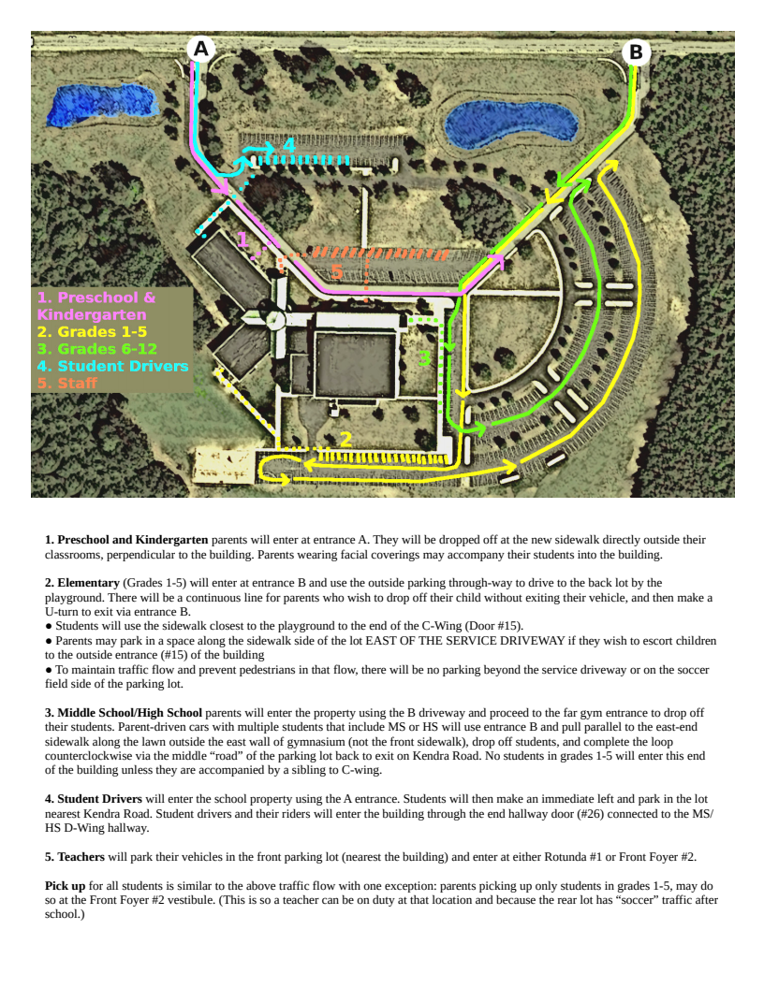

MAINTAINING COHORTS*:

CCS will carefully manage enrollment for 2020-2021 to allow social distancing within cohort-size classroom spaces. Even if the average cohort grew to 18, there would be under 250 students within our 70,000 square feet of indoor educational space.
- Students will remain with their cohorts for lunch in their classrooms or in outdoor venues, weather permitting.

DAILY TOUCHLESS TEMPERATURE CHECKS: Students will enter their classrooms with masks on, remain masked while the teacher takes their temperature with a touchless thermometer, and records (but does not announce) the temperature.
- Temperatures of >100.4: Students will remain masked and go directly to the sick bay (see below). The teacher will notify the office, who will contact the parents to pick up their student
- Temperatures of 100.0-100.4: The student will remain masked in the classroom and the teacher will recheck his or her temperature within the class period. If the student’s temperature remains elevated, the student will proceed to the sick bay.

PHYSICAL DISTANCING:

In the context of individual cohorts, physical distancing will be an important deterrent to viral spread, as will frequent use of outdoor education venues.

Band and choir classes have been relocated to accommodate generous physical distancing requirements unique to those activities and class sizes.
- The senior class homeroom has been relocated to accommodate generous physical distancing requirements unique to their class sizes.

Physical distancing protocols (especially to whatever extent such distance reduces the potential need for masks) will be followed whenever possible. Disinfecting and hygiene protocols shall follow any deviations from those protocols.

FACIAL COVERINGS:

Masks are required to enter the building, and will be worn in all indoor common areas and individual cohort settings where physical distancing is not possible.

Exceptions will be made during snack time, lunch, and scheduled breaks, or if a waiver (see below) is provided by a licensed health professional, counselor, or occupational therapist.
- CCS will provide disposable masks (50 cents) for students who do not have one on their person. All masks should have the student’s name on them.
- Homemade cloth masks must be part of a supply that allows for laundering after each day’s use.
- MASK WAIVERS:
  - As per the MI Safe Schools Michigan’s 2020-21 Return to School Roadmap*, CCS will accept without prejudice any notes provided by a student’s licensed health professional, counselor, occupational therapist, etc., regarding the wearing of masks. No stigma or unprofessional discussion will be allowed regarding exemption from mask wearing under such circumstances.
  - Likewise, discretion will be extended to students/parents who may request proximity precaution regarding students who cannot wear PPE.

FREQUENT DISINFECTING:

Teachers will disinfect work spaces and equipment between each change of cohorts.

Other common areas, such as playground and recess equipment, will be disinfected between changes of cohorts.
- Common areas such as hallways and bathrooms will be disinfected multiple times during the day.

MODERN HVAC: Our HVAC (Heating, Ventilation, and Air Conditioning) system will be programmed for maximum fresh air intake as per local Health Department recommendations.

NEW ROOM ASSIGNMENTS:

To reduce cross-traffic between cohort groups, entirely new room assignments have been made, assigning elementary classes to the smaller C-Wing, and middle/high school classes to the longer D-Wing. Locker assignments will keep student cohorts in their new wings and as close to their classrooms as possible.

Because it is considered a “common area,” the library was moved to room A-100 in the rotunda.

The computer lab was dismantled, and the desk-top computers distributed among all classrooms for student use. Computer classes will be conducted with Chromebook laptops (which are kept on a cart) in cohort classrooms. There will also be personally assigned Chromebooks - currently backordered - for the high school.

The first two classrooms on the right of the D-Wing are exclusively Kindergarten and Preschool, with a new sidewalk for direct outside access from the front sidewalk. Pending school board approval, 12 x 24’ gazebo over the new sidewalk will be added for protection from the elements.

MOVEMENT WITHIN THE BUILDING:

Inside the building, masks must be worn in all common areas shared by multiple cohorts. (This remains true even if individuals are alone in that common area.)

HYGIENE: Frequent personal hygiene/hand washing shall be taught and practiced at all grade levels. Hand sanitizer stations will be posted at each room entrance for use when entering and exiting rooms. Personal hand sanitizer will be kept in student desks (K-5) and in personal carry items for grades 6-12.

RESTROOMS:

When possible, HS students will be encouraged to use the large restrooms in the “flag foyer” outside the gym, decreasing traffic in the D-wing restrooms.

C-wing restrooms will be reserved exclusively for elementary students all day.

Exclusive-use times for preschool-kindergarten will be scheduled while the D-Wing hall is unoccupied.

LIMITING LOCKER TIME:

Students will not linger in hallways before class in the morning or throughout the day. Plans are in place to limit the necessity for locker access, therefore limiting extended close contact in hallways. Additionally, masks will be worn at all times in hallways.

Middle/high school students may hang their coats on foyer racks, band instruments, athletic gear, art materials, etc. may be shelved as directed in proper places. Locker time must be brief as students quickly gather materials and proceed directly to their first hour classroom.
OUTDOOR VENUES:

Daily routines have been designed to maximize the advantages of small cohorts, ample indoor space, and beautiful outdoor spaces.
- TABLES: Ten steel 8’ picnic tables (matching three we have) will be in the two pavilions at the rear (west end) of the rotunda courtyard. Five will be in shaded areas around the building. Twelve lighter-weight 6’ picnic tables will be placed inside the D-wing pavilions (six in each).
- PAVILIONS: Two 20 x20 outdoor education pavilions will be available in the rear courtyard, and two for use of MS and HS near D-wing. While these are snow-load bearing structures, they are not permanent structures, and can be repurposed post-Covid.
- OUTDOOR PE will be recommended whenever possible.
- During school hours, only single cohorts will use the playground or outdoor equipment at one time.

PICK UP AND PARKING

Pick up for all students is similar to the above traffic flow with one exception: parents picking up only students in grades 1-5, may do so at the Front Foyer #2 vestibule. (This is so a teacher can be on duty at that location and because the rear lot has “soccer” traffic after school.)

As always, to ensure efficient traffic flow, parents who must exit their vehicles are asked to please use designated parking spaces and not leave vehicles unattended in drop-off/pick-up lines.

RELATED UPDATES AND RECOMMENDATIONS:
- A new Sick Bay will be set up between the “emergency use only” rear rotunda glass doors. Any student who has a temperature of 100.4 or more will wait there, the office will monitor students via video while parents are called to pick up. Parents will use the rear sidewalk where they can talk with the office via speakerphone without needing to enter the building. Student privacy and staff compassion will set the tone for this process. In any “normal” year, dozens of students go home due to mild illness.
- Each teacher will be provided a $50 cash allowance to purchase their own PPE devices (masks) of their own choosing for use during the school day.
- CCS will provide a clear face screen and rubber gloves for all teachers to be worn while disinfecting rooms with Coronavirus killing solution.
- ATTENDANCE: As always, faithful attendance will be encouraged. However, the number of absences will not affect student progress if they meet all other enrollment expectations.
- CCS will follow the Muskegon County Health Department protocols as they pertain to the information regarding documented cases that have had contact with the CCS building.
- CCS is a long-standing member of the MHSAA. All athletic transportation, testing, and occupancy guidelines established by the MHSAA will be followed.
- CCS is an accredited member of the ACSI and AdvanceED and as such is an approved SEVIS school for International students. As such, I-20 forms cannot be issued for on-line learning but only for in person/on-campus classes

These changes and reopening protocols accommodate educational best practice and are intended to ensure a safe, secure, and productive educational environment.

*Whitmer, Governor Gretchen & Return to School Advisory Council. (2019). COVID-19 Task Force on Education. Advisory Council MI Safe Schools Michigan’s Return to School Roadmap. Retrieved from https://www.michigan.gov/documents/whitmer/MI_Safe_Schools_Roadmap_FINAL_695392_7.pdf
Public Health- Muskegon County COVID-19 Return to School Toolkit. Retrieved from https://www.co.muskegon.mi.us/DocumentCenter/View/10019/_COVID-19-Return-to-School-Toolkit__PHMC_08-05-2020-w-Appendixes?bidId=

